6

Rule Book

- GAME

1. At the start of each game, captains from both teams meet
at midfield for the coin toss to determine who starts with
the ball. The visiting team calls the toss.

2. The winner of the coin toss has the choice of offense or
defense. The loser of the coin toss has the choice of
direction. Possession changes to start the second half
to the team that started the game on defense.

3. The offensive team takes possession of the ball at its 5-yard
line and has three (3) downs to cross midfield. Once a team
crosses midfield, it has three (3) downs to score a touchdown.

4. If the offense fails to score, after crossing midfield the ball
changes possession and the new offensive Team starts at its 5-yard line

5. Teams change sides after the first half. Possession changes
to the team that started the game on defense.

- Terminology
Boundary Lines - The outer perimeter lines around the field. They include the sidelines and back of the end zone lines.

Line of Scrimmage - (LOS) an imaginary line running through the point of the football and across the width of the field.

Line-to-Gain - The line the offense must pass to get a first down or score.

Rush Line - An imaginary line running across the width of the field seven yards
(into the defensive side) from the line of scrimmage.

Offense - The team with possession of the ball.

Defense - The team opposing the offense to prevent it from advancing the ball.

Passer - The offensive player that throws the ball and may or may not be the quarterback.

Rusher - The defensive player assigned to rush the quarterback to prevent him/ her from passing the ball by pulling his/her flags or by blocking the pass.

Live Ball - Refers to the period of time that the play is in action. Generally used
in regard to penalties. Live ball penalties are considered part of the play and must be enforced before the down is considered complete.

Dead Ball - Refers to the period of time immediately before or after a play.

Whistle - Sound made by an official using a whistle that signifies the end of the play or a stop in the action for a timeout, halftime or the end of the game.

Inadvertent Whistle - Official’s whistle that is performed in error.

Charging - An illegal movement of the ball-carrier directly at a defensive player who has established position on the field. This includes lowering the head or initiating contact with a shoulder, forearm or the chest.

Flag Guarding - An illegal act by the ball-carrier to prevent a defender from pulling the ball-carrier’s flags by stiff arm, lowering elbow or head or by blocking access to the runner’s flags with a hand, arm or ball.

Shovel Pass - A legal forward pass across the LOS underhand, backhand or by pushing the ball forward.

Lateral - A backward or sideway toss of the ball by the ball-carrier.

Unsportsmanlike Conduct - A rude, confrontational or offensive behavior or language.

- Equipment

1. All players must wear official NFL TEAM Jersey, Shorts, Socks, FLAG belts and flags. All players MUST wear mouth guards at all times while on the field. Game balls should be age specific.

2. Players must wear shoes. Cleats may not be allowed at certain locations. This will be specified by your league organizer or site director. However, cleats with exposed metal are never allowed and must be removed.

3. Players may tape their forearms, hands and fingers. Players may wear gloves, elbow pads and knee pads. Braces with exposed metals are not allowed.

4. Players must remove all jewelry, hats and do-rags. Winter beanies are allowed.

5. Players may wear soft shell helmets but they must be secured at ALL times while on the playing field

6. Players’ jerseys must be tucked into shorts or pants if they hang below the belt line.

7. Participants must bring their own official NFL FLAG belts and mouth guards to the field. Extra belts and mouth guards may be available for purchase.

8. NFL FLAG footballs will be provided.

- Flag belts and flags cannot be the same color as the shorts.

- Field

1. The field dimensions are 30 yards wide by 70 yards with two 10-yard end zones
The center line is midfield line to gain. No Run zones are located five yards prior to the line to gain and five yards prior to the end zone in the offense’s direction.
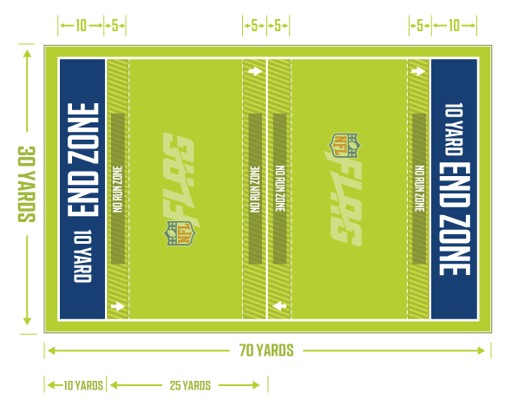

2. No-run zones are in place to prevent teams from conducting power run plays. While in the no-run zones (a 5-yard imaginary zone before midfield and before the end zone), teams cannot run the ball in any fashion. All plays must be pass plays, even with a handoff.

3. Stepping on the boundary line is considered out of bounds.

4. Each offensive team approaches only TWO no-run zones in each drive (one zone 5 yards from midfield to gain the first down, and one zone 5 yards from the goal line to score a TD).

- TIMING AND OVERTIME

1. Regular Season Games are played on a 40-minute continuous clock with two 20-minute halves, unless one team gains a 35-point advantage which will end the game. The clock stops for halftime, injuries and the Officials’ discretion.

2. Halftime is 8 minutes.

3. Each time the ball is spotted, a team has 40 seconds to snap the ball.

4. Each team has 2 60-second timeout per game.

5. Officials can stop the clock at their discretion.

6. In the event of an injury, the clock will stop then restart when the injured player is removed from the field of play.

7. If the score is tied at the end of regulation play, an overtime period will be used to determine winner. Overtime format is as follows:

a. Home team calls the toss to determine the team that chooses to be on offense or defense first. If a second round of overtime must be played, the team that lost the coin toss will get to choose offense or defense for the start of the second round of overtime. This process continues with teams alternating who gets to choose to be on offense or defense to start out during every round of overtime. The referee will determine which end of the field the overtime will take place on.

b. Each team will take turns getting one (1) play from the defense’s 5-yard line for one point or the defense’s 10-yard line for two points. Whether to go for one or two points is up to the offensive team. Whether or not the team that begins on offense converts the team that started on defense gets a chance on offense to win or tie by converting a one- or two-point play of their own.

i. Example: Team A starts on offense and chooses to go for one point from the 5-yard line and is successful. Team B is then on offense and can choose to either go for one point from the 5-yard line to tie and force a second round of overtime or to go for two points from the 10-yard line for the win.

ii. If the second team on offense in an overtime round fails to beat or match the team that went first, the team that went first wins.

c. Starting with the 2nd overtime, both teams must "go for two" from the 10-yard line

d. Starting with the 3rd overtime, each team will get 1 play from the 5 yard line going out from the end zone. The team with the most yards will be the winner. The team with the most yards will be awarded 1 point added to their final score.

e. Final Score will be recorded to include all points scored for each team

f. All regulation period rules and penalties are in effect.

g. There are no timeouts.

h. Interceptions are returnable in OT, and worth 2 points
.
i. Interceptions returned for a score in the first or second overtime period.
ii. Interceptions advanced from the possession point in the third overtime period
- Each team has one rules challenge for the entire overtime session.

- Scoring

1. Touchdown: 6 points

2. PAT (point after touchdown) 1 point (5-yard line) or 2 points (10-yard line)
a. Note: 1 point PAT is pass only; 2 point PAT can be run or pass.

3. Interceptions returned for scores during regular game play are worth six points, conversions or overtime are worth two points

4. Safety: 2 points
a. A safety occurs when the ball-carrier is declared down in his/her own end zone. Runners can be called down when their flags are pulled by a defensive player, a flag falls out, they step out of bounds, their knee or arm touches the ground, a fumble occurs in the end zone or if a snapped ball lands in or beyond the end zone.

5. A team that scores a touchdown must declare whether it wishes to attempt a 1-point
conversion (from the 5-yard line) or a 2-point conversion (from the 10-yard line). Any change, once a decision is made to try for the extra point, requires a charged timeout. A decision cannot be changed after a penalty.

6. After one team is winning by 35 points or more, the game is over. Once a 35 or more point advantage is gained, no PAT will be attempted.

7. Forfeits are scored 35-0 for the winning team.

8. The coaches, officials and scorekeeper must sign the score sheet. If a coach does not sign the score sheet before leaving the field, the scorekeeper will note on that score sheet and the score will be FINAL.

- Coaching
VII. Coaches
1. Coaches are expected to adhere to NFL FLAG philosophies, coaching guidelines
and code of conduct.

2. Coaches are permitted to Coach on the sideline.

a. All team photographers, managers, position coaches, team moms, fans, etc. are required and must remain a minimum of 10 yards off the field in a designated viewing area.

- Coaches, this is your responsibility to keep your fans and any other team associated members in the designated areas.

- Live Ball/Dead Ball

1. The ball is live at the snap of the ball and remains live until the official whistles the ball dead.

2. The official will indicate the neutral zone and line of scrimmage.

a. It is an automatic dead ball foul if any player on defense or offense enters the neutral zone. In regard to the neutral zone, the official may give both teams a “courtesy” neutral zone notification to allow their players to move back behind the line of scrimmage.

3. A player who gains possession of the ball in the air is considered in bounds as long as the first foot or other body part contacts the ground in the field of play.

4. The defense may not mimic the offensive team signals by trying to confuse the offensive players, while the quarterback is calling out signals to start the play. This will result in an unsportsmanlike conduct penalty.
5. Substitutions may be made on any dead ball.

6. Any official can whistle the play dead.

7. Play is ruled “dead” when:

a. The ball hits the ground.

- If the ball hits the ground as a result of a bad snap, the ball is then placed where the ball hit the ground.

b. The ball-carrier’s flag is pulled.

c. The ball-carrier steps out of bounds.

d. A touchdown, PAT or safety is scored.

e. The ball-carrier’s knee or arm hits the ground.

f. The ball-carrier’s flag falls out.

g. The receiver catches the ball while in possession of one or no flag(s).

h. The 7 second pass clock expires.

i. Inadvertent whistle

j. Ball-carrier leaves their feet other than jump cuts, spinning or to avoid a downed player on the field of play.

NOTE: There are no fumbles. The ball becomes a dead ball. (If the ball is fumbled forwards then it will be spotted where the ball carrier lost possession.

8. If inadvertent whistle occurs the offense has two options:

A) take the ball where the whistle blew and the down is consumed

B) replay the down from the original line of scrimmage. If it occurs on the last play of the half or game, the offense will be awarded one untimed down and given those two options.

9. A team is allowed to use a timeout to question an official’s rule interpretation. If the official’s ruling is correct, the team will be charged a timeout. If the rule is interpreted incorrectly, the timeout will not be charged and the proper ruling will be enforced. Officials should all agree upon any controversial call in order to give each team the full benefit of each call.

10. Officials should all agree in order to change a call on the field that is in dispute

- Running

1. The ball is spotted where the ball is when the flag is pulled.

2. The quarterback cannot directly run with the ball. The quarterback is the offensive player who receives the snap.

3. Only direct handoffs behind the line of scrimmage are permitted. Handoffs may be in front, behind or to the side of the offensive player but must be behind the line of scrimmage. The offense may use multiple handoffs.

4. Pitch or lateral of any kind must occur behind the line of scrimmage .

5. No-run Zones are located 5 yards before each end zone and 5 yards on either side of midfield are designed to avoid short-yardage power-running situations. Teams are not allowed to run in these zones if the subsequent line is LIVE. (Reminder: Each offensive team approaches only TWO no-run zones in each drive – one 5 yards from midfield to gain the first down and one 5 yards from the goal line to score a TD).

6. Runners may not leave their feet to advance the ball. Diving, leaping or jumping to avoid a flag pull is considered flag guarding.

7. Spinning/Jump Cuts are allowed, but players cannot leave their feet to avoid a flag pull.
a. Players spinning out of control will be called for flag guarding.

8. Ball carriers may leave their feet and the play will continue for spinning, jump cuts, QB’s passing progression or if there is a clear indication that he/she has done so to avoid a collision with another player and the play will continue without stoppage.

9. No blocking or “screening” is allowed at any time.

10. Offensive players in close proximity of the ball-carrier must stop their motion once the ball has crossed the line of scrimmage. No running with the ball-carrier.

11. Flag obstruction – All jerseys MUST be tucked in before play begins. The flags must be on the player’s hips and free from obstruction. Deliberately obstructed flags will be considered flag guarding

12. Any player who receives a handoff can throw the ball from behind the line of scrimmage
.
13. Once the ball has been handed off in front, behind or to the side of the quarterback,
all defensive players are eligible to rush.

- Passing

1. All passes must be thrown with one hand from behind the line of scrimmage, thrown
forward and ball out of hand prior to breaching the line of scrimmage.

a. There is no intentional grounding
b. All passes that do not cross the line of scrimmage, whether received or not,
are illegal forward passes, unless touched by a defender.
c. The quarterback may throw the ball away to avoid a sack. Pass must go beyond the line of scrimmage.

2. Shovel passes are allowed but must be received beyond the line of scrimmage.

3. The quarterback has a seven-second “pass clock.” If a pass is not thrown within the seven seconds, the play is dead, the down is consumed and the ball is returned to the line of scrimmage. Once the ball is handed off, the 7-second rule is no longer in effect.

- If the QB is standing in the end zone at the end of the 7-second clock, the ball is returned to the line of scrimmage (LOS).

- If the quarterback throws the ball and then catches it, the play is dead and treated like an incomplete pass.

- Receiving

1. All players are eligible to receive passes (including the quarterback if the ball has been handed off behind the line of scrimmage).

2. Only one player is allowed in motion at a time. All motion must be parallel to the line of scrimmage and no motion is permitted toward the line of scrimmage.

3. A player must have at least one foot or other body part in bounds, contacting the ground first with possession.

4. In the case of simultaneous possession by both an offensive and defensive player, possession is awarded to the offense.

5. Interceptions are returnable. If returned for a score during regular game play, the score will be worth six points, two points if returned during conversions and/or overtime.

- Rushing the Passer

1. All players who rush the passer must be a minimum of seven yards from the line of scrimmage when the ball is snapped. Any number of players can rush the quarterback. Players not rushing the quarterback can defend on the line of scrimmage.

2. Once the ball is handed off, the seven-yard rule no longer is in effect and all defenders may go behind the line of scrimmage.

3. A special marker, or the referee, will designate a rush line seven yards from the line of scrimmage. Defensive players should verify they are in the correct position with the official on every play.

- A legal rush is:
- Any rush from a point 7-yards from the defensive line of scrimmage.

ii. A rush from anywhere on the field AFTER the ball has been handed off by the quarterback.

b. A penalty may be called if:

i. The rusher leaves the rush line before the snap and crosses the line of scrimmage before a handoff or pass – illegal rush (5-yards from the line of scrimmage and first down).

ii. Any defensive player crosses the line of scrimmage before the ball is snapped –off sides (5-yards from line of scrimmage and first down).

iii.Any defensive player not lined up at the rush line crosses the line of scrimmage before the ball is passed or handed off – illegal rush (5-yards from the line of scrimmage and first down).

iv. Any defensive player not lined up at the rush line crosses the line of scrimmage before the ball is passed or handed off – illegal rush (5-yards from the line of scrimmage and first down).

- Special circumstances:

- Teams are not required to rush the quarterback with the seven second clock in effect.

ii. Teams are not required to identify their rusher before the play.

4. Players rushing the quarterback may attempt to block a pass; however, contact to the QB,unless ruled incidental by the official, would result in a roughing the passer penalty.

5. The offense cannot impede the rusher in any way. The rusher has the right to a clear path to the quarterback, regardless of where they line up prior to the snap. The PATH is set pre-snap from the rusher or rushers directly to the QB. PATH does not move once the quarterback moves. If the “path or line” is occupied by a moving offensive player, then it is the offense’s responsibility to avoid the rusher. Any disruption to the rusher’s path and/or contact will result in an impeding the rusher penalty. If the offensive player does not move after the snap, then it is the rusher’s responsibility to go around the offensive player and to avoid contact.

6. A sack occurs if the quarterback’s flags are pulled behind the line of scrimmage.
The ball will be spotted where possesion of the ball is once the flag is pulled.

  - A Safety is awarded if the sack takes place in the offensive team’s end zone.

- Flag Pulling

1. A legal flag pull takes place when the ball-carrier is in full possession of the ball.

2. Defenders can dive to pull flags but cannot tackle, hold or run through the ball-carrier when pulling flags.

3. It is illegal to attempt to strip or pull the ball from the ball-carrier’s possession at any time.

4. If a player's flag inadvertently falls off during a play while that player has possession,
the player is down immediately and the play ends. The ball is placed where the flag lands.

5. If a player who has one or no flags in their belt takes possession of the ball, the play is dead at that spot on the field.

6. A defensive player may not intentionally pull the flags off of a player who is not in
possession of the ball.

7. Flag guarding is an attempt by the ball-carrier to obstruct the defender’s access to the flags by stiff arming, dropping the head, hand, ball, arm or shoulder or intentionally covering the flags with the football jerseys.

- Formations

1. Offenses must have a minimum of one player on the line of scrimmage (the center) and up to four players on the line of scrimmage. The quarterback must be off the line of scrimmage.

a. Teams may shift formations prior to the snap as long as they are set for at least 1 second before the ball is snapped.

- One player at a time may go in motion at least 1 yard behind the line of scrimmage.

2. Movement by a player who is set or a player who runs toward the line of scrimmage
while in motion is considered a false start.

3. The center must snap the ball with a rapid and continuous motion between his/her
legs to a player in the backfield, and the ball must completely leave his/her hands.

- Unsportsmanlike Conduct

1. If the field monitor or referee witnesses any acts of intentional tackling, elbowing, cheap shots, blocking or any unsportsmanlike act, the game will be stopped and the player will be ejected from the game. The decision is made at the referee’s discretion. No appeals will be considered. FOUL PLAY WILL NOT BE TOLERATED!

2. Offensive or confrontational language is NOT allowed. Officials have the right to determine offensive language. If offensive or confrontational language occurs, the officials will determine if a warning or immediate ejection is warranted.

3. Players may not physically or verbally abuse any opponent, coach or official.

4. Ball-carriers MUST make an effort to avoid defenders with an established position.

5. Defenders must give free releases off the line of scrimmage to offensive players
and are not allowed to run through the ball-carrier when pulling flags.
ROUGH PLAY WILL NOT BE TOLERATED

6. Fans must also adhere to good sportsmanship as well:

a. Yell to cheer on your players, not to harass officials or other teams.

b. Keep comments clean and profanity free.

c. Compliment ALL players, not just one child or team.

7. Fans are required to keep fields safe and kids friendly:

a. Keep younger kids and equipment such as coolers, chairs and tents a minimum of 10 yards off the field in the end zone area.

b. Stay in the end zone area, not between fields.

- Dispose of ALL trash in designated trash cans.

8. Unsportsmanlike conduct penalties:

a.Defense + 10 yards from line of scrimmage and automatic first down

b. Offense - 10 yards from line of scrimmage and loss of down

- Penalties

- General

- The referee will call all penalties.

- Referees determine incidental contact that may result from normal run of play.

- All penalties will be assessed from the line of scrimmage, except as noted.
(Spot fouls)

- Only the team captain or head coach may ask the referee questions about rule clarification and interpretations. Players may not question calls.

- Games or halves may not end on a defensive penalty unless the offense declines it.

- Penalties are assessed live ball then dead ball. Live ball penalties must be assessed before play is considered complete.

- Penalties will be assessed half the distance to the goal yardage when the penalty yardage is more than half the distance to the goal.

- Spot fouls in end zone: Defensive (Ball on one-yard line, first down)/Offensive (Safety)

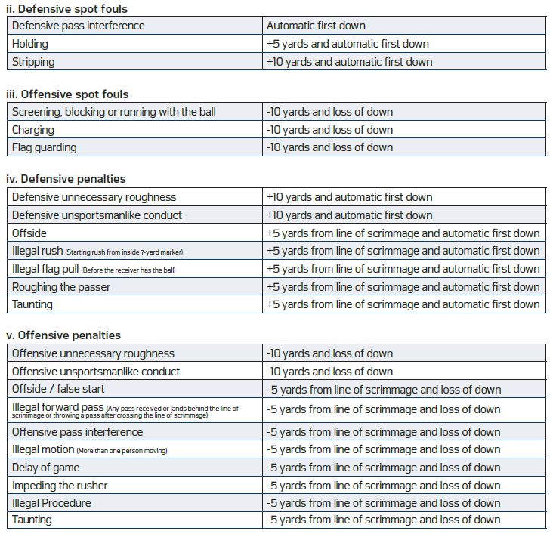

- Division Guidelines

- 6u Division

- Defenders may NOT rush the passer unless there is a legal handoff executed in the backfield.

- Defenders MUST line up at least five yards from the line of scrimmage prior to the snap, unless the offense has entered the no run zone, at which point the defender is allowed to defend from the line of scrimmage.

- One Coach for each team is permitted on the field

- If the ball falls to, or touches the ground during the initial center to quarterback exchange, the play is ruled a ‘Do Over’ with no loss of down, once per down. On a second consecutive occurrence, the down is consumed

- 8u Division

- Defenders may rush the passer but must follow the rushing rules located in section XII Rushing the Passer.

- One Coach for each team is permitted on the field

- All other rules apply

- 10u,12u,14u Divisions

- Coaches must coach from the sidelines.

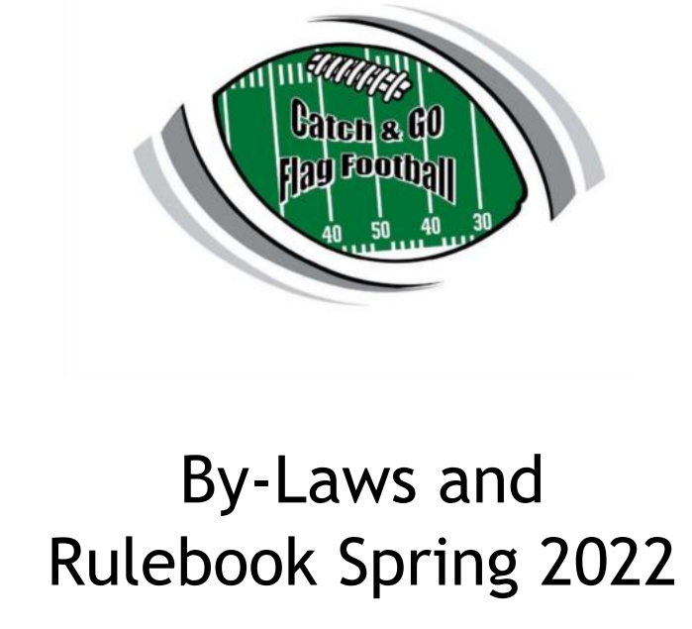
CATCH AND GO LEAGUE RULES AND BYLAWS

CATCH & GO FLAG FOOTBALL BY-LAWS AND RULEBOOK

Mission
Catch and Go of Yuma aims to provide the youth in and around our community an opportunity to learn the game of football through the safety of non-contact flag football where good sportsmanship is promoted and healthy habits are created. Kids ages 5-14 are given top notch football skill training through the help of our volunteer coaches and volunteers. A member of the NFL Flag of Arizona, Catch and Go of Yuma also helps to develop the first phase of player and coach development through the many resources provided by NFL Flag and training from various High School coaches in our area. Our goal is to create the best quality that a youth program can offer in a community like Yuma.

I.LEAGUE DEVELOPMENT AND BOARD MEMBERS
A.Board Members are responsible for developing league rules/by-laws and making sure that the rules/by-laws are being followed.

The following positions are recognized by Catch & Go Flag Football:

1.President
2.Vice President
3.Secretary / Treasurer
4.Equipment Manager
5.Uniform Coordinator
6.Director of Coaching
8.Information Technology

B.Board members must be a minimum of 21 years of age.

C.Responsibilities include:

1.Having emergency contact information for all participants at all league functions, games and practices.

2.Ensuring the certified roster is accurate and up to date in the league database. He/she shall work with American Youth Football (AYF) and the National Football League (NFL) prior to the first game to ensure that all rosters are in order and accurate.

3.Documenting any player/coach injuries occurring during league functions, games and practices.

4.Ensuring all league taxes, income, donations and expenses are documented and/or filed for the renewal of tax exempt 501(c)(3) status.

5.Ensuring all league documentation is in order.

6.Providing training for board members, coaches, and volunteers.

II.COACHES/VOLUNTEERS
Coaches/Volunteers do not make the policies of Catch & Go Flag Football but are there to carry them out.

A.Head Coach

1.The Head Coach must be a minimum of 21 years of age.

2.Head Coach are required to be registered with the league in sports connect

3.The Head Coach is responsible for:

a.His/her team’s players, assistant coaches and volunteers.

b.determining the assignments of assistant coaches and volunteers.

c.The actions of assistant coaches, players, cheerleaders, team parents/spectators and volunteers at team functions (i.e. practices, games and team parties).

d.The safety and actions of all players.

e.Organizing all practices during the season.

f.Maintaining its team sidelines to include parent/spectator control and cleaning up after games.

B.Assistant Coach/Volunteer:

1.Assistant Coaches must be a minimum of 18 years of age.

2.Volunteers must be a minimum of 16 years of age.

3.All volunteers are required to be registered with the league in Sports Connect

3.Assistant Coach/Volunteer is responsible for:

a.Assisting Head Coach with practices.

b.During the games, Assistant Coaches/Volunteers must make players stay out of unauthorized areas of the game fields.

III.BACKGROUND CHECKS

A.All board members, coaches, referees, and volunteers must submit a signed Coach
and Volunteer Form.

B.All board members, coaches, officials, and volunteers will be required to undergo
a criminal history check.

C.Board members are responsible for conducting criminal history checks and
establishing qualifying/disqualifying standards.

IV.DIVISIONS OF PLAY AND REGISTRATION

A.Catch & Go Flag Football uses the divisions outlined below:
6 Division (5/6yr old) 8u Division (7/8yr old)
10u Division (9/10yr old) 12u Division (11/12yr old)
14u Division (13/14yr old) 9-11u Girls Division (9-11yr old)
12-14u Girls Division (12-14yr old)
*the league reserves the right to adjust divisions based off the number of registered participants per division
B.Division Age Qualification are based off the age of the athlete as of Jan 1 of the current year.
Example: If you are age 8 on January 1 of this year but turn 9 anytime after Jan 1 you would be eligible to play in the 8u division.

C.All Registrations will be done online through Sports Connect found on league website

D.Participants must complete all registration forms, e-signing all waivers and paying all required registration fees prior to participating in any Catch and Go sanctioned activity.

E.No player may practice with a team until he/she has officially registered with Catch & Go Flag Football.

F.Catch and Go reserves the right to request an original copy of participants birth certificate for age verification

V.TEAM FORMATION

A.A team shall have a maximum of three (3) coaches/volunteers, of which one (1) must be a head coach and two (2) may be an assistant coach or volunteer approved by the board.

B.Required starting team size should be a minimum of five (5) players and a maximum of ten (10) players. A maximum of twelve (12) players may be allowed depending on the ratio between players/teams. No more than twelve (12) players will be allowed on a team.

C.Catch & Go Flag Football requires that all players play during a game, but it is up
to the coach to determine playing time.

D.The team may consist of any player that meets the requirements for the division for which the team is in.

E.Once a player becomes certified for an age division, that player will not be permitted to transfer to another division or team within the same division, unless authorized by the board.

VI.ADDS AND DROPS

A.Mandatory drops - any player must be dropped from the team, who:

1.Is found to have signed up as a result of parental pressure or tells a
coach/volunteer he/she does not really want to participate.

2.Attempts to intimidate fellow participants by word or physical deeds.

3.Is an extreme disciplinary problem.

B.Voluntary drops - Any player/cheerleader may be dropped and/or will be considered voluntarily dropped when:

1.He/she requests to be dropped.

2.He/she no longer shows up to practices and/or games.

C.If any team drops more than three (3) players, throughout the course of a season, it will be reviewed by the board to ensure coaches/volunteers are running their teams according to the values set forth in these policies.

D.NO REFUND will be given once registration has been closed

VII.PRACTICES

A.Practice locations/times will be determined by the head coaches.

B.Prior to the start of games, a practice start date will be announced for the season

C.Any practice that occurs prior to the official season start date is not considered sanctioned by the league and attendance will not be held against the athlete

C.Once games have started, practices will be held a minimum of one (1) day per week and maximum of two (2) days per week.

D.Practices may not be longer than two (2) hours per day.

E.In the event the Head Coach cannot attend a practice, he/she must:

1.Make arrangements with one of the other league approved coaches/volunteers on the team to carry out practice.

2.Advise the other coaches/volunteers of the practice plan and/or what areas to work (i.e. drills, offense, defense, conditioning, etc.).

F.Weather Precautions
1.Teams are to guard against serious heat related problems and must provide water for all participants at all times.

2.Coaches must:

a.Give players water breaks every twenty (20) minutes.

b.Watch for signs of heat exhaustion or fatigue.

c.Promote the non-usage of energy drinks (i.e. Monster, Red Bull, etc.) at any time.

d.Make available, Ice and water, at all times.

VIII.LEAGUE RULES

A.The rules contained herein are to be enforced by all Catch & Go Flag Football
representatives.

B.The season will be determined by the Catch & Go Flag Football board.

C.Rule changes will be made by board members. If a rule is amended, all coaches
will be notified of the change. Rule changes can only take place prior to and after
the season. NO CHANGES WILL BE MADE DURING THE SEASON!

XIII.GAME SCHEDULES

A.Game schedules will be developed by the board and handed out prior to the season.

B.All schedule changes need to be approved by the board and changed prior to the season.

IX.GAME/EVENT DAY

A.The Head Coach is responsible for game day football activity.

B.Pre-game checklist
1. 5 minutes prior to the start of each game, both teams will meet at the center of the playing field for inspection of required equipment (i.e. NFL FLAG jersey/flags, cleats with no metal spikes, mouthpiece, and league issued shorts) and rosters. Each child should be lined up in the order of the team’s certified roster (alphabetical order). The Referees and Head Coaches will conduct the inspection.

2.Coaches will provide referees with certified rosters at game time.

ONLY LEAGUE APPROVED COACHES/PLAYERS ARE
ALLOWED ON THE FIELD/SIDELINE!!!

3.If a player does not have the required equipment, that player may not play in the game until said player has fixed the equipment issue and has presented himself/herself to the opposing team’s Head Coach.

WEATHER CANCELLATIONS

We will make every attempt to make the call on weather cancellations by 7:00 a.m. on game days. All weather updates will be posted on the league website, Facebook and Instragram pages. Head Coaches will be notified by email and are responsible for making notice to their teams. There may be times where cancellations will be made at the field prior to, or during games at the Referee’s, Field Supervisor’s and/or Board Member’s discretion.

X.POST-SEASON
A.All teams will be eligible for post-season play.

B.Tie-breakers within the division for seeding purposes will be determined as follows:

1.Win-Loss record

2.Head-to-head record

3.Points against

4.Coin toss – Board members will conduct coin toss at the end of the season

XI.CODE/RULES OF CONDUCT

A.CODE OF CONDUCT
All board members, coaches, team members, parents, officials, and staff members will
abide by a Code of Conduct established by Catch & Go Flag Football Policies, which
includes the provisions contained in these policies. If any of these policies and/or rules is
broken, the Catch & Go Flag Football board members shall have the authority to impose
sanctions on said individuals or teams. Some but not all points in the Code of Conduct
include:

1.Coaches family members, parents, and spectators are required to observe the game from the designated areas. All participants, coaches and family members must conduct themselves appropriately during games

2.Coaches must adhere to our guidelines mention in the in this rule book,

3. Inappropriate, rude or confrontational behavior by any coach, team or parent may lead to the to disqualification of the game.

4.Accept the decision of the game officials on the field as being fair and called to the best ability of said officials.

5.No criticizing an opposing team, its players, coaches or fans with words or gestures.

6.All team representatives shall be responsible for the conduct of team fans and spectators. Any fan who becomes a nuisance and out of control will be asked to leave the facilities. Failure to do so may result in your team forfeiting the game.
7.Abusive and/or profane language will not be tolerated

8. Participation by an ineligible player will result in forfeiting games in season play, and if found during end of season playoffs/tournament, the entire team will be forfeited from the entire event.

9. Deliberately inciting unsportsmanlike conduct

10. Abstain from the possession and drinking of alcoholic beverages and/or the use and possession of any tobacco products and illegal substances on both the game and practice fields.

11. Remove from a game or practice any participant, when even slightly in doubt about his/her health, whether or not as a result of an injury, until competent medical advice is available. Any player who receives ANY head injury MUST be cleared by a doctor or EMT before returning to play.

B.RULES OF CONDUCT

1.Board Members, Field Supervisors, Referees, or any other officials that work for Catch & Go Flag Football will provide incident reports to the Executive Board on any of the infractions listed below. These following guidelines pertain to anyone in attendance at a Catch & Go Flag Football event:

•Ejection from Game = Minimum 1 game suspension

•Unsportsmanlike Conduct = Possible 1 game suspension

•Profanity = 1 game suspension

•Threatening an Official = Season suspension

•Hitting an Official = Indefinite suspension (no less than 1 year)

•Drinking/Public Intoxication = Season suspension

•Fighting (on/off field) = Indefinite suspension (no less than 1 year)

•Second Offense #1, #2, and #3 = Season suspension

•Playing an Ineligible Player = Loss of game(s) in which player participated and possible action against the coach, team, and association.
•Participation of an Ineligible Coach = Loss of game(s) in which coach participated and possible action against the coach, team, and association.

2.The Executive Board, after review of incident reports, will carry
out the above penalties and suspension.

3.In the event that a team fails to respect the game Officials’ authority or decisions, game Officials have been instructed to call a forfeit in favor of the opposing team after one (1) warning has been given.

4.If an Official ejects a coach or spectator from a game, that person will be asked to leave the field area. If a person refuses to leave, the game will be forfeited (opposing team wins), and the police will be notified.

5.Any player, coach, or team associated with a person caught and proven guilty of cheating or misrepresenting any record will be suspended indefinitely.

6.Any type of fighting will result in immediate expulsion from the league for the rest of the season. Any other behavior such as cursing, disrespect to game Officials, or any other action deemed inappropriate by game Officials or league officials will not be tolerated. Any of these behaviors can result in the following:
ejection from the game, suspension for the rest of the season, and expulsion from all Catch & Go Flag Football events (i.e. league, camp/clinics, and tournament).

